INDIE GAME MARKETING
BUDGET & STRATEGY ANALYSIS

A Competitive Intelligence Report for
ECHOSCAPE (Steam Release)

Prepared for:
ECHOSCAPE | Investor Pitch Support

March 2026 | Confidential

Executive Summary
This report provides a comprehensive analysis of marketing budgets, competitive landscape, and recommended strategy for an independent meditation and wellness game targeting the Steam platform. The analysis draws on publicly available Steam review data, industry norms from games marketing practitioners, and documented case studies from both comparable competitors and broader indie market outliers.
The meditation game niche on Steam is lightly competed, with the majority of titles spending little to nothing on formal marketing. This creates a meaningful opportunity for a well-resourced first-mover to establish category leadership, if they can cross the discovery threshold that most competitors have failed to clear.

Key Findings at a Glance
10 of 14  Competitors with <200 reviews | 21K–54K  PLAYNE estimated unit sales | $15–40K  Recommended mktg budget | 10–50×  ROI potential vs. peers

KEY | Spending $15,000–$40,000 on marketing, more than almost every direct competitor, is achievable on a modest budget and could reasonably establish category leadership on Steam within this niche.

Investment Relevance
For investor discussions, the core pitch is straightforward: the meditation game category on Steam is wide open. The market leader (PLAYNE) achieved its position with a nearly zero cash marketing budget, earning 1,000+ reviews organically over four years. A deliberate, funded campaign of $20,000–$40,000 targeted at wellness audiences, a demographic that barely overlaps with traditional gaming press, could reasonably achieve 3–5× PLAYNE's review velocity within the first year.

Market Context: The Indie Gaming Landscape
Understanding the broader indie market backdrop is essential before examining the meditation niche specifically.

Steam Indie Market at a Glance (2024)
The indie game market on Steam has grown dramatically in scale and sophistication. A few data points set the scene:
- Indie games represented 99% of all Steam releases in 2024, but only 48% of revenue — illustrating extreme concentration at the top.
- The top 8% of successful indie games account for approximately 80% of revenue (Pareto / power law distribution).
- Only ~0.5% of all 2024 indie releases are estimated to be financially viable without supplementary revenue.
- Median third-game revenue for a returning indie team is $209K — significantly higher than first-game ($120K) or second-game ($168K) releases.

CONTEXT | The market is both crowded and polarized. Most games earn almost nothing; a small number earn everything. The critical driver of which side you land on is discoverability -- and discoverability is driven by wishlists, influencer pickup, and Steam algorithm signals.

The Meditation / Wellness Niche
Within the broader indie market, meditation and wellness games occupy a thin but coherent sub-genre. The category benefits from:
- Low competition: Most competitors are solo hobbyists or micro-teams with minimal marketing. The bar to become the category's most visible title is low.
- Cross-market appeal: The target audience extends well beyond traditional gamers — mindfulness practitioners, therapists, mental health advocates, and wellness content creators are all reachable via non-gaming channels.
- Press differentiation: Gaming journalists rarely cover this niche. Psychology and wellness publications (healthline, Verywell Mind, mindful.org) represent an entirely untapped earned media channel.
- Gift and institutional potential: Meditation tools have gift purchase potential (mental health gift-giving is a growing category) and potential B2B applications (corporate wellness, therapist recommendation).

Competitor Analysis: Steam Performance
The following analysis uses Steam review counts as the primary performance metric. The standard Boxleiter Method estimates unit sales by multiplying review count by 20 (conservative) to 50 (optimistic), based on industry research into reviewer-to-buyer conversion rates.
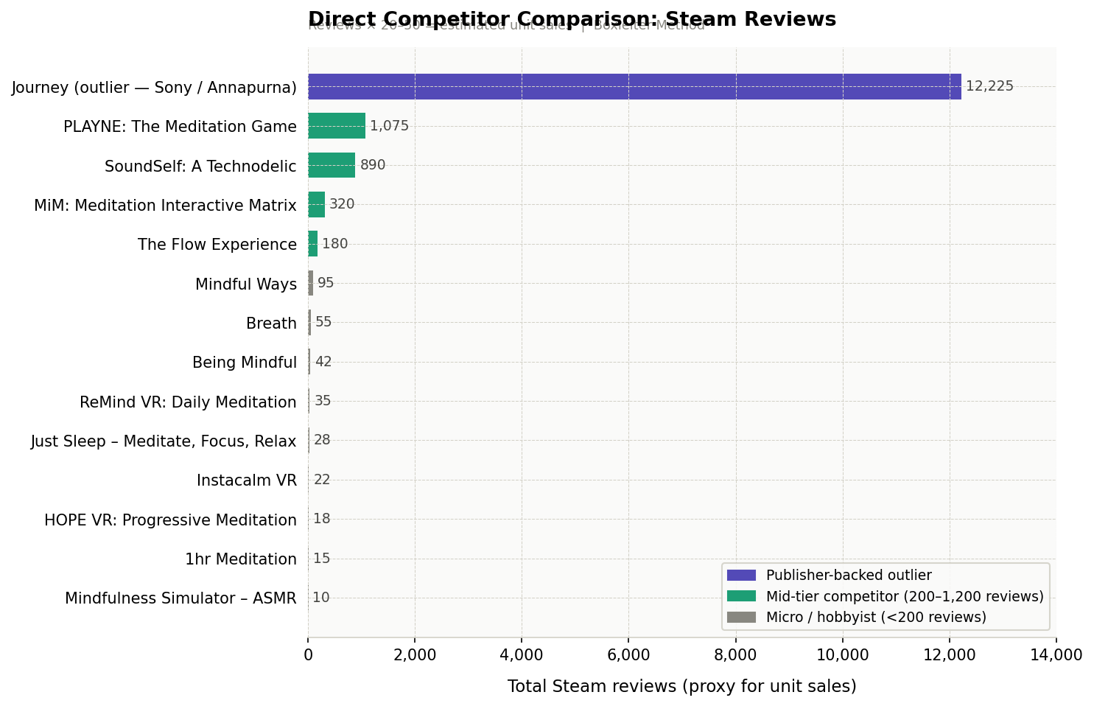
Figure 1: Direct competitor Steam review counts. Reviews × 20–50 = estimated unit sales.

Competitor Snapshot Table

Game | Reviews | Est. Sales | Price | Dev Type | Mktg Est.
PLAYNE: The Meditation Game | 1,075 | 21K–54K | $14.99 | Solo dev | $5–25K (organic)
SoundSelf: A Technodelic | 890 | 18K–45K | $14.99 | Small team | $10–30K
MiM: Meditation Int. Matrix | 320 | 6K–16K | $9.99 | Small team | $2–10K
The Flow Experience | 180 | 4K–9K | $7.99 | Solo | $1–5K
Mindful Ways | 95 | 2K–5K | $4.99 | Hobbyist | <$1K
Breath | 55 | 1K–3K | $2.99 | Hobbyist | <$500
Being Mindful | 42 | 840–2K | $3.99 | Hobbyist | <$500
ReMind VR: Daily Meditation | 35 | 700–2K | $9.99 | Solo VR | <$1K
Just Sleep – Med. Focus Relax | 28 | 560–1.4K | $5.99 | Hobbyist | <$500
Instacalm VR | 22 | 440–1.1K | $9.99 | Solo VR | <$500
HOPE VR: Progressive Med. | 18 | 360–900 | $9.99 | Solo VR | <$500
1hr Meditation | 15 | 300–750 | $1.99 | Hobbyist | $0
Mindfulness Simulator – ASMR | 10 | 200–500 | $4.99 | Hobbyist | $0
Journey (outlier / benchmark) | 12,225 | 244K+ | $14.99 | Sony backed | $1M+ (Sony)

Note: Marketing estimates are inferences based on studio size, development approach, and observed outreach. Actual figures are not publicly disclosed.

Key Observations
- PLAYNE is the benchmark: As the clear category leader, PLAYNE demonstrates that organic marketing (Early Access community building + press outreach) can achieve 1,000+ reviews. Its VR DLC addition and BAFTA filmmaker backstory gave it an earned media angle that cost nothing.
- SoundSelf found a different angle: By leaning into the "psychedelic tech" positioning and attending niche events (including Sundance's VR showcase), it carved out a dedicated audience distinct from the pure meditation crowd.
- The floor is very low: 10 of 14 direct competitors have fewer than 200 reviews — suggesting either genuine lack of audience or, more likely, near-zero marketing investment. These titles are not real competition if you have any marketing budget at all.
- VR titles are underperforming: Despite the immersive fit, VR meditation titles show worse traction than flatscreen equivalents — likely due to the smaller addressable VR market on Steam.

Marketing Budget Tiers: Industry Framework
The games marketing industry has established consistent tiers based on the relationship between development budget, studio size, and marketing investment. These norms are drawn from practitioner guidance, developer post-mortems, and agency-published benchmarks.
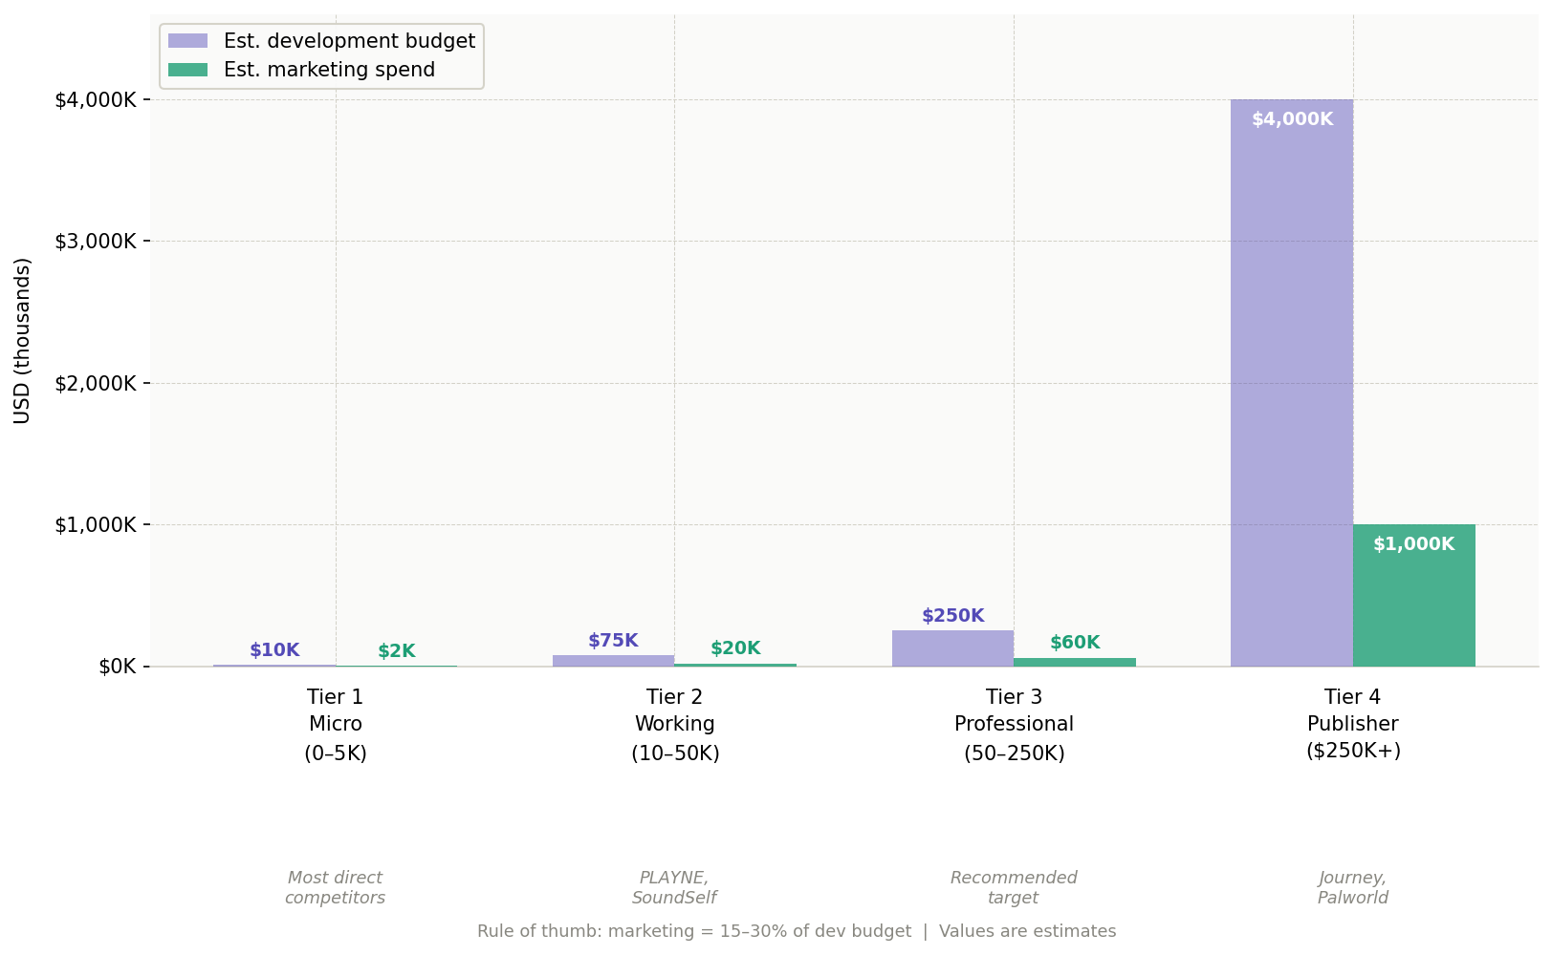
Figure 2: Marketing spend vs. development budget across indie tiers. Log-scale values for outliers.

Tier Definitions

Tier | Marketing Budget | Who Uses It | What It Gets You
Tier 1 Micro | $0 – $5K | Solo / hobbyist devs. Most direct competitors. | Steam page, organic social, free key distribution. Minimal paid reach.
Tier 2 Working | $10K – $50K | PLAYNE, SoundSelf tier. Small professional teams. | Influencer outreach (paid & seeded), PR coverage, targeted social ads, polished trailer.
Tier 3 Professional | $50K – $250K | Mid-market indie publishers. Recommended ceiling. | PR agency, multi-tier influencer strategy, events, UA campaigns. Full launch marketing.
Tier 4 Publisher | $250K+ | Publisher-backed titles (Journey/Annapurna, etc.). | Multi-channel campaigns, dedicated team, major events, merchandise, global PR.

The Rule of Thumb
The widely cited industry standard is that marketing investment should equal 15–30% of the total development budget. For perspective:
- A game developed for $50,000 should invest $7,500–$15,000 in marketing.
- A game developed for $150,000 should invest $22,500–$45,000 in marketing.
- A solo developer's time has value: a $50,000 marketing "budget" includes ~$30,000 of developer time at market rates, plus $20,000 in actual cash spend.

RULE OF THUMB | For every $1.00 spent on development, plan to spend $0.25–$0.50 on marketing. Studios that under-invest typically cite "the game should speak for itself" — which almost never happens in a 13,000-title annual release environment.

High-Spending Outliers & Case Studies
While direct competitors operate on minimal budgets, examining both high-spending outliers and organic breakout successes provides critical strategic intelligence for investor conversations.
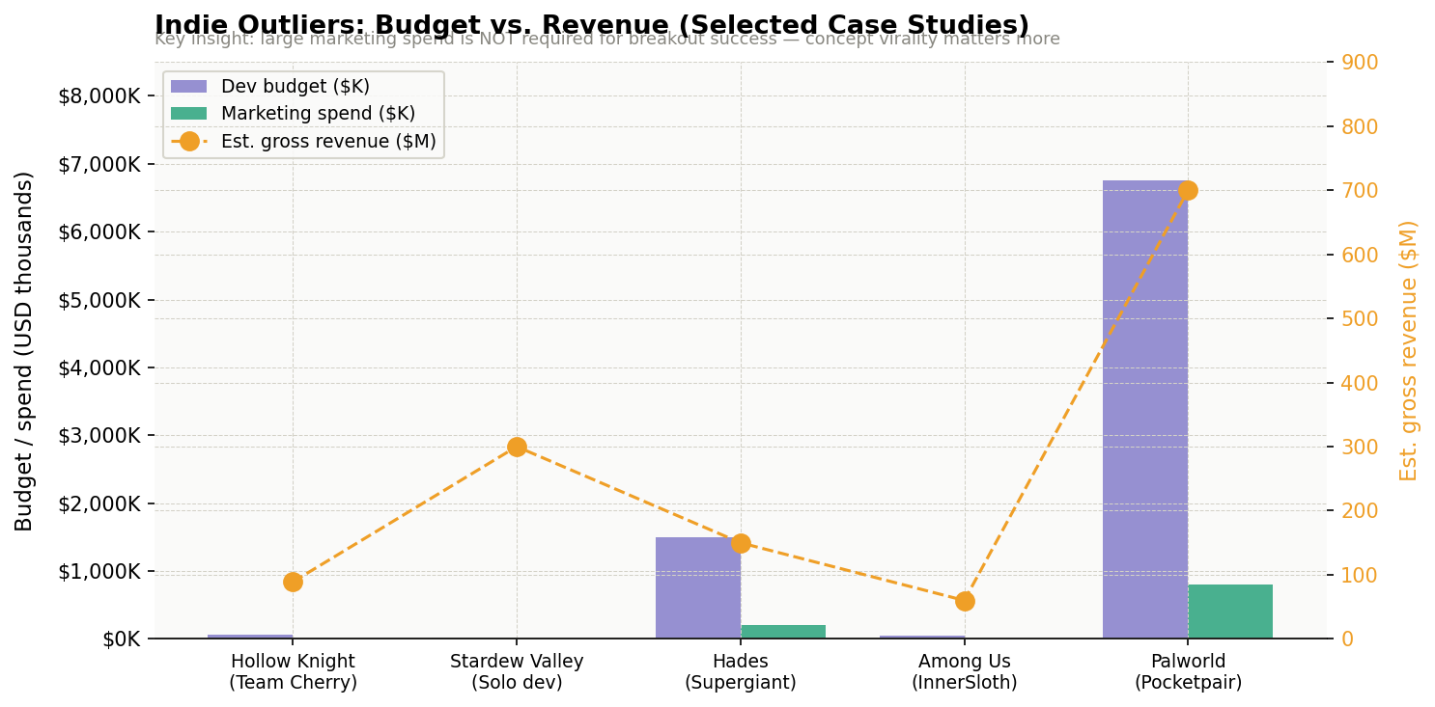
Figure 3: Indie outlier case studies — development budget vs. marketing spend vs. gross revenue estimate.

Case Study: Palworld (Pocketpair, 2024)
Palworld is the most instructive recent case. With a total combined budget of approximately $6.75M (development and marketing combined), Pocketpair achieved 25 million players within a month of launch. The CEO has confirmed the game has generated "tens of billions of yen" in profit, roughly 10–30× the total investment. Crucially, Palworld's marketing was not primarily paid, it was viral controversy (comparisons to Pokémon), streamer pickup, and a bold pre-launch trailer testing strategy. The lesson: concept virality and streamer friendliness outperform paid media at scale.

Case Study: Hollow Knight (Team Cherry)
Developed for under $60,000 with a marketing budget of approximately $5,000, Hollow Knight has generated over $89M in estimated gross revenue and 6+ million copies sold. Team Cherry's entire marketing strategy was: Kickstarter backers as early advocates, GDC presence, and developer transparency via social media. Near-zero cash, enormous ROI. The caveat: this took several years to build, and the game was exceptionally well-reviewed.

Case Study: Among Us (InnerSloth)
Among Us launched in 2018 with essentially zero marketing spend and sold a handful of copies. Two years later, organic TikTok and Twitch pickup turned it into a global phenomenon with 500+ million downloads. The lesson for wellness games: communities like mindfulness subreddits, mental health Discord servers, and wellness TikTok can serve the same organic seeding function, and are currently entirely untapped by meditation game developers.

Case Study: Journey (thatgamecompany / Sony)
Journey is the genre outlier -- a Sony-published title with a marketing budget an order of magnitude above anything in the direct competitor set. It's the aspirational ceiling for what this category can achieve artistically and commercially. On Steam (via Annapurna Interactive), it has 12,000+ reviews, validating that a premium, award-winning meditation-adjacent experience can find a massive audience. It should not be modeled as a marketing benchmark, but it proves audience appetite at scale.

INVESTOR NOTE | The data from outlier case studies consistently supports one conclusion: marketing budget alone does not determine success. Concept clarity, community seeding, and earned media (press + influencer) outperform paid advertising at this budget level. A $25K–$40K campaign deployed smartly across the right channels can deliver outsized results.

Recommended Marketing Strategy
Based on the competitive landscape, budget tier analysis, and case study data, the following strategy is recommended for a first-time meditation game launch on Steam. The approach is optimized for a Tier 2 working budget of $15,000–$40,000 in cash, supplemented by significant developer time.

Recommended Budget Allocation
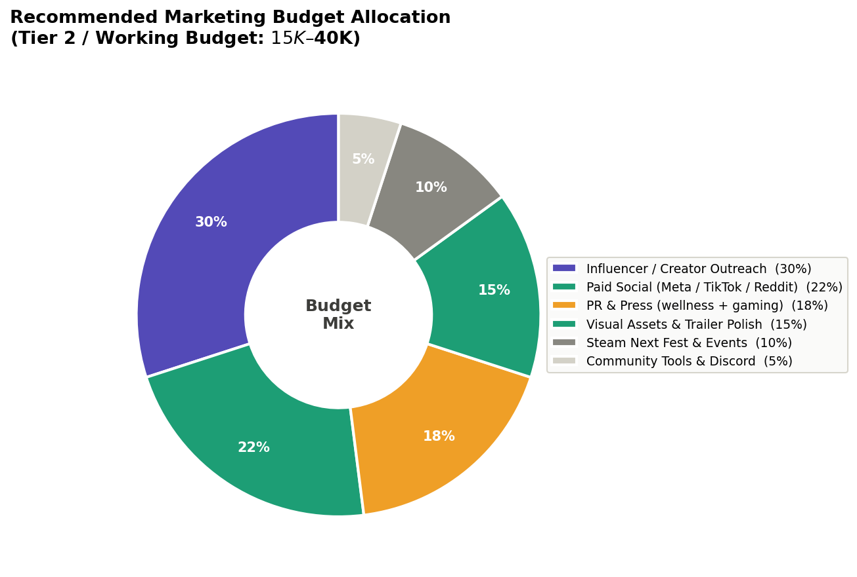
Figure 4: Recommended marketing budget allocation for a Tier 2 indie meditation game launch.

Category | Allocation | Budget ($25K base) | Key Activities
Influencer & Creator Outreach | 30% | $7,500 | Mindfulness YouTubers, wellness TikTok, relaxation Twitch streamers. Mix of seeded (free keys) and 2–3 paid micro-sponsorships.
Paid Social Advertising | 22% | $5,500 | Meta + TikTok ads targeting meditation app users, yoga communities. Run $500/week in the 2 weeks flanking launch.
PR & Press Outreach | 18% | $4,500 | Pitch to both gaming press (Kotaku, RPS) AND wellness press (Mindful, Healthline). A PR freelancer for 3 months.
Visual Assets & Trailer | 15% | $3,750 | Professional capsule art, launch trailer edit, GIF library for social. This is what gets people to click on Steam.
Events & Steam Next Fest | 10% | $2,500 | Steam Next Fest participation (free but requires lead time). Optional: 1 indie showcase or wellness conference.
Community / Tools | 5% | $1,250 | Discord server setup, mailing list tool (Mailchimp), Steam key management platform.

Pre-Launch Marketing Timeline
Marketing should begin no later than 12 months before the intended launch date. The Steam wishlist is the primary pre-launch performance metric, a target of 7,000–10,000 wishlists before launch provides a healthy launch-day sales foundation.

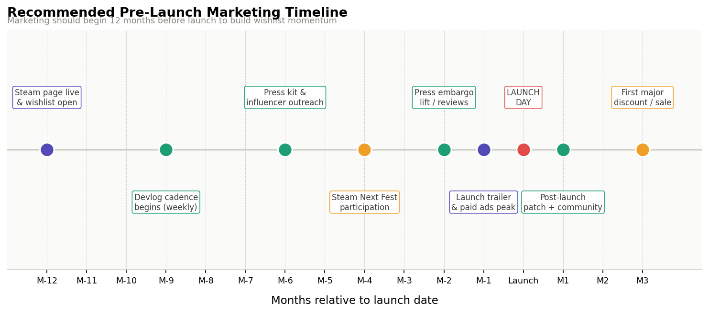
Figure 5: Recommended pre-launch marketing timeline. Begin 12 months out to build wishlist momentum.

The Wellness Media Angle: An Untapped Differentiator
The single most underutilized marketing opportunity in this niche is wellness media. While every meditation game developer has attempted to get into gaming press (RPS, Kotaku, PC Gamer), none appear to have systematically targeted:
- Mental health publications: Healthline, Verywell Mind, Psychology Today
- Mindfulness and meditation platforms: Mindful.org, Lion's Roar, Tricycle
- Mental health podcasts: where a developer interview could reach 50K+ engaged listeners
- Therapist and counselor communities: professional networks where "games for mental health" is an active topic
- Corporate wellness decision-makers: HR managers and EAP coordinators who purchase tool licenses for employees

BEST PRACTICE | Secure 2–3 quotes from licensed mental health professionals willing to endorse the game's potential benefits. These are invaluable for wellness press pitches, and they cost nothing except relationship building. PLAYNE successfully did this — "Playne provides a unique platform for mindfulness" from Dr. Jean-Luc Williams, Psy.D.

Best Practices & Tactical Playbook

Steam Page Optimization (Free, High Impact)
- Capsule art is everything: Users decide in 3–5 seconds. Invest $500–$1,500 in professional capsule design. Do not launch with developer-made art unless you have strong design skills.
- Keyword strategy: Use terms like "relaxation," "mindfulness," "meditation," "stress relief," "calming" in your tags, description, and title. These map to how your non-gaming audience searches.
- Trailer timing: The first 15 seconds of your trailer must show what the experience feels like — not a features list. Lead with atmosphere.
- Wishlist CTA everywhere: Every social post, every influencer mention, every press piece should include a direct wishlist link. Wishlists are Steam's primary discoverability signal.

Influencer Strategy
- Avoid large gaming streamers: A $10K sponsorship with a 500K-subscriber variety streamer will almost always underperform compared to spending that same $10K across 20 smaller creators who genuinely love relaxation and wellness content.
- Target wellness creators first: YouTube channels focused on ASMR, sleep, meditation, and anxiety will have audiences with dramatically higher purchase intent for a game in this niche than gaming-focused channels.
- Seed keys aggressively: Send 200–500 free Steam keys to creators before launch. Keys cost nothing. Even a 2% conversion rate on 500 creators means 10 content pieces generated.
- Track with UTM links: Use unique referral links for each creator so you know which channels are actually converting to wishlists and purchases.

Steam Next Fest
Steam Next Fest is a free festival Valve runs multiple times per year where upcoming games offer demos. Participating in Next Fest can generate:
- 5,000–50,000 demo plays depending on visibility (median for non-featured indie: ~2,000–5,000)
- Significant wishlist additions — often 20–40% of a game's total wishlists
- Press coverage, as journalists use Next Fest to discover upcoming titles
Participation requires a playable demo 2+ months in advance and registration on Steam. Budget your demo build timeline accordingly.

Community Building (Pre-Launch)
- Discord first: Launch a Discord server the day your Steam page goes live. It becomes your most engaged community and provides valuable feedback for development.
- Dev log cadence: Post weekly development updates — to Steam, Reddit (r/indiegaming, r/gamedev, r/meditation), and your newsletter. Consistency signals that the game is real and actively developed.
- Subreddit seeding: r/meditation has 800K+ members. A well-crafted post showing your game with genuine engagement (not spam) can generate thousands of wishlist additions for free.
- Early Access consideration: PLAYNE used Early Access successfully to build community and iterate. For a meditation game, EA can work well if there is a meaningful core loop available at launch. Avoid EA if the game is content-sparse.

AVOID | The most common budget mistake: spending on broad paid ads before the Steam page converts well. Fix your page, get your trailer right, and validate organic interest first. Running Facebook ads to a poor-converting Steam page is like pouring water into a leaky bucket.

Investor Pitch Notes: Marketing Ask
This section summarizes the key data points and narrative framing recommended for an investor pitch seeking marketing funding. The goal is to demonstrate category knowledge, realistic expectations, and a clear use-of-funds plan.

The Opportunity Frame
The meditation and wellness game category on Steam represents a genuine white space. The category leader (PLAYNE) achieved its position through organic community building over 4+ years — with no dedicated marketing budget. A deliberate, funded campaign of $20,000–$40,000 is significantly more than any direct competitor has spent, and could realistically establish category leadership in 12–18 months post-launch.

Competitive Moat Argument
- 10 of 14 direct competitors have fewer than 200 Steam reviews — representing minimal installed base and community.
- No competitor has meaningfully pursued wellness media (psychology press, mindfulness publications, therapist communities) — an entirely untapped channel.
- The broader wellness app market (Calm, Headspace) demonstrates massive willingness to pay for digital mental wellness tools — Steam pricing ($10–$20) is dramatically lower than subscription apps, with no recurring revenue required from the user.

Use of Marketing Funds

Budget Line | Amount | Purpose & Expected Outcome
Influencer & Creator | $7,500–$12,000 | Seed 300–500 wellness & gaming creators; 2–3 paid micro-sponsorships at launch. Expected: 15–25 organic content pieces, 5,000–15,000 wishlist additions.
Paid Social Advertising | $5,000–$8,000 | Meta + TikTok targeting meditation app users. Run heaviest spend in the 14 days around launch. Expected: 3–8× ROAS at $10–$15 CPI.
PR & Press Outreach | $4,000–$8,000 | Freelance PR for 3 months covering gaming and wellness press. Expected: 10–20 press placements including 2–3 wellness publications.
Visual Assets | $3,000–$6,000 | Professional capsule art, launch trailer edit, screenshot library. One-time spend with lasting impact on Steam conversion rate.
Events & Next Fest | $2,000–$4,000 | Steam Next Fest demo build + optional 1 indie showcase. Expected: 2,000–8,000 additional wishlists from festival visibility.
Community & Tools | $1,000–$2,000 | Discord, newsletter, key management. Infrastructure for long-term community growth.
TOTAL | $22,500–$40,000 | Full Tier 2 launch campaign. Positions the game above all direct competitors in marketing investment.

Expected Outcomes
These projections are illustrative targets, not guarantees. They are grounded in Boxleiter Method reverse-engineering of competitor performance and standard indie launch benchmarks.

7,500+  Target wishlists at launch | 5,000–15,000  Year-1 unit sales target | $65K–$200K  Year-1 gross revenue est. | 5–20× more  vs. typical competitor

PITCH FRAME | We are not asking for marketing budget because we don't know how to market — we are asking because we have done the homework. Every direct competitor has underinvested. We know exactly where the audience is, what channels to use, and what a win looks like. This investment goes directly to execution.

Risk Acknowledgment
Investors should note the following risks, which represent standard indie game launch risks rather than factors specific to this project:
- Discovery risk: Even with marketing investment, Steam's algorithm is not predictable. Wishlist conversion to purchases varies by genre, timing, and competitive release calendar.
- Audience crossover uncertainty: Meditation app users and Steam users are partially overlapping populations. The wellness media channel is untested in this category — which is the opportunity, but also the risk.
- Category ceiling: Based on PLAYNE's performance, the realistic ceiling for a solo meditation game on Steam is approximately 50,000–100,000 lifetime units without a major platform breakout. Revenue ceiling is approximately $750K–$1.5M gross at a $14.99 price point.

Appendix: Methodology & Sources

Steam Sales Estimation Methodology
Unit sales estimates in this report use the Boxleiter Method: multiplying a game's public Steam review count by a factor of 20 (conservative) to 50 (optimistic). This method is widely used in the games industry and validated by developers who have shared both their review counts and actual sales figures. The multiplier varies by genre, price point, and release era. For casual and relaxation games, a multiplier of 30–40 is generally considered accurate.

Marketing Budget Estimation
Competitor marketing budget estimates are inferences based on: (1) studio size and type (solo/hobbyist vs. small team), (2) visible press coverage and influencer engagement, (3) platform and event presence, and (4) industry norms for studios of comparable scale. No competitor has publicly disclosed their marketing expenditure.

Industry Sources Referenced
- GAMES.GG: "Game Marketing Budget: How Much Should You Spend" (February 2026)
- Game Developer Magazine: "The Realistic Guide to Pricing Indie Game Marketing" (December 2023)
- VG Insights: "Global Indie Games Market Report" (October 2024)
- GameDiscoverCo / Gamalytic: Top 50 indie games analysis by tier (2024)
- Pocketpair CEO blog post on Palworld budget via Insider Gaming (January 2024)
- Steam platform data: PLAYNE, SoundSelf, competitor pages (March 2026)
- GAM3S.GG: "Indie Games on Steam Make Up 48% of Revenue" (December 2025)

Competitor Games Analyzed
Game | Steam App ID (approx) | Price | Release Year
PLAYNE: The Meditation Game | 865540 | $14.99 | 2020
SoundSelf: A Technodelic | 1380280 | $14.99 | 2020
Mindfulness Simulator – ASMR | 1916690 | $4.99 | 2022
Being Mindful | 1369580 | $3.99 | 2020
Mindful Ways | N/A | $4.99 | 2021
Just Sleep – Meditate, Focus, Relax | N/A | $5.99 | 2022
1hr Meditation | N/A | $1.99 | 2022
ReMind VR: Daily Meditation | N/A | $9.99 | 2022
Instacalm VR | N/A | $9.99 | 2021
HOPE VR: Progressive Meditation | N/A | $9.99 | 2022
Breath | N/A | $2.99 | 2021
MiM: Meditation Interactive Matrix | N/A | $9.99 | 2023
The Flow Experience | N/A | $7.99 | 2023
Journey (benchmark outlier) | 638230 | $14.99 | 2019 (Steam)

This report was prepared in March 2026 for internal strategic use.
Data estimates are subject to change as new information becomes available.

